Introduction to HTTP

HTTP is a core operational protocol of the world wide web. It is what enables your web browser to communicate with a web server that hosts a website. HTTP is the communication protocol you use whenever you browse the web. HTTP stands for Hypertext Transfer Protocol. It is a protocol used for transferring web resources such as HTML documents, images, styles, and other files. HTTP is a request response based protocol. A web browser or client sends an HTTP request to a server and the web server sends the HTTP response back to the browser.

Next, let's start exploring the makeup of an HTTP request.
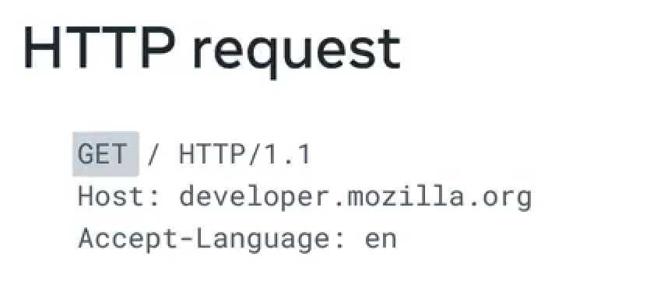

An HTTP requests consists of a method, path, version and headers. The HTTP method describes the type of action that the client must performed. The primary or the most commonly used HTTP methods are, GET, POST, PUT, and DELETE.

The GET method is used to retrieve information from the given server.
The POST request is used to send data to the server. The PUT method updates whatever currently exists on the web server with something else. The DELETE method removes the resource. The path is the representation of where the resource is stored on the web server. There are multiple versions of the HTTP protocol (Versions 1.1 and 2.0 are the most used).

Headers contain additional information about the request and the client that is making the request. For certain requests methods, the request will also contain a body of content that the client is sending.

Now, let's cover some details about the makeup of an HTTP response. HTTP responses follow a format similar to the request format.
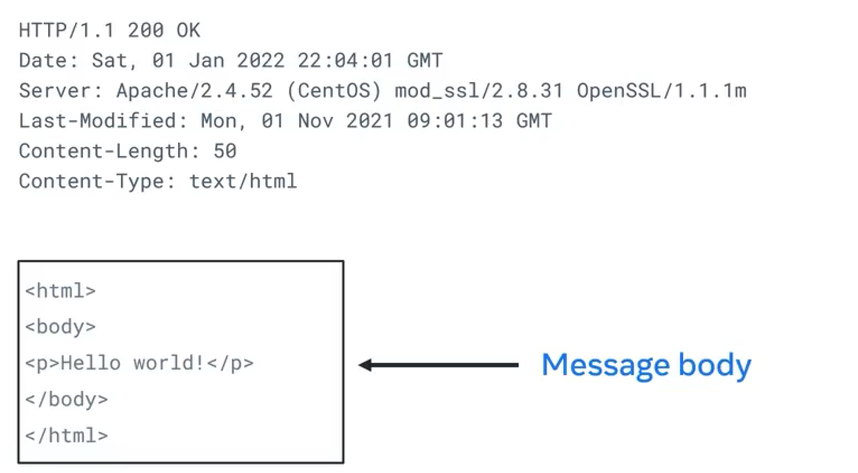
Following the header, the response will optionally contain a message body consisting of the response contents such as the HTML document, the image file and so forth. HTTP status codes contained within the header indicate if the HTTP request successfully completed. The code values are in the range of 100-599 and are grouped by purpose.

The status message is a text representation of the status code. These are HTTP status codes. There are five groups of status codes. They are grouped by the first digit of the error number.
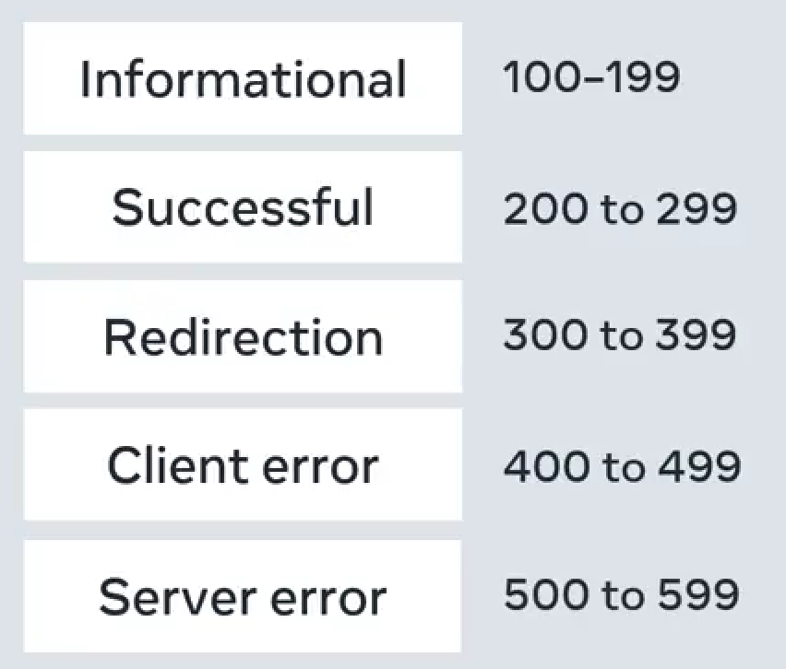
Information responses are provisional responses sent by the server. These responses are interim before the actual response. The most common information response is 100 continue, which indicates that the web client should continue to request or ignore the response if the request is already finished.

Successful responses indicate that the request was successfully processed by the web server, with the most common success response being 200 OK. You're receiving these responses every day when you receive content successfully from a website. The meaning of OK, depends on the HTTP method. If the method is GET, it means that the resource is found and is included in the body of the HTTP response. If it's POST, it means that the resource was successfully transmitted to the web server and if it's PUT, the resource was successfully transmitted to the web server. Finally, if the method is DELETE, it means the resource was deleted.

Redirection responses indicate to the web client that the requested resource has been moved to a different path. The most common response codes used are 301 moved permanently and 302 found. The difference between the redirection messages 301 and 302 is that 302 indicates a temporary redirection.The resource has been temporarily moved.

When web browsers receive these responses, they will automatically submit the request for the resource at the new path. Client error responses indicate that the requests contained bad syntax or content and cannot be processed by the web server. The most common codes used are 400 is used when the web browser or client submitted bad data to the web server, 401 is used to indicate that the user must log into an account before the request can be processed, 403 is used to indicate the request was valid, but that the web server is refusing to process it. This is often used to indicate that a user does not have sufficient permissions to execute an action in a web application, 404 is used to indicate that the request resource was not found on the web server.

Server error responses indicate that a failure occurred on the web server while trying to process the request. The most common code used is 500 internal server error, which is a generic error status indicating that the server failed to process the request.

HTTPS is the secure version of HTTP. It is used for secure communication between two computers so that nobody else can see the information being sent and received. It does this by using something called encryption. Like in HTTP, the requests and responses still behave in the same way and have the same content. The big difference is that before the content is sent, it is turned into a secret code. Only the other computer can turn the secret code back into its original content. If someone else was to look at the code, it wouldn't be understandable.You use HTTPS every day. This is the lock icon you see beside the URL in your web browser.

